Final Report 

**SOME Billing System**

##### PREPARED FOR

North South University

##### PREPARED BY

Sadman Sakib Khan Promit

Course: CSE327 || Section:

Group:

**Table of Contents**

### Table of Contents i

Table of Contents  i 2

**1.** **Introduction 1**

1.1 Purpose of the Document 1

1.2 Scope of the document 1

1.3 Overview 1

1.4 Intended Audience and Use 1

1.5 Product Scope 1

1.6 Definitions and Acronym 2

1.7 References 2

**2.** **Overall Description 2**

2.1 Product Perspective 2

2.2 User Classes and Characteristics 3

2.3 Operating Environment 3

2.4 Design and Implementation Constraints 3

2.5 User Documentation 4

2.6 Assumptions and Dependencies 4

**3.** **System Features and Requirements 4**

3.1 Functional Requirements 4

3.2 External Interface Requirements 5

3.3 System Features 5

3.4 Business Rules 6

3.5 Nonfunctional Requirements 6

**4.** **System Modelling Diagrams 7**

4.1 Context Diagram 7

4.2 Use Case Diagram 8

4.3 Activity Diagram 9

4.4 State Diagram 10

4.5 Sequence Diagram (Customer) 11

4.6 Sequence Diagram (Management/Admin) 12

4.7 ER Diagram 13

**5.** **Interactive Wireframing 14**

5.1 SOME Portal 14

5.2 Customer Register 15

5.3 Customer Login Page 16

5.4 Customer Information 17

5.5 View Monthly Bill 18

5.6 Make Payment 19

5.7 Management Login 20

5.8 Registration Success Screen 21

5.9 Manage Account 22

5.10 Bill Management 23

**6.** **Functionality wise Prototype Description 24**

6.1 Admin Functions 24

● 6.1.1 Delete User Account 24

● 6.1.2 Edit Billing Rate 25

25

∙ 6.1.3 Veiw User’s Billing Information 25

6.2 Customer Function 26

∙ 6.2.1 Download/Veiw Billing Reports in PDF Formate 26

6.3 Implemented Login/Sign up 26

∙ 6.3.1 System Login 26

∙ 6.3.2 System Sign Up 27

**27**

**Contribution Table 28**

# Introduction

## Purpose of the Document

This Software Requirements Specification (SRS) document's main goal is to give a thorough explanation of the website ‘Electricity Billing System for SOME’ that was developed as the CSE327 course's term project.

## Scope of the document

The document specifies the requirements and features of the website titled ‘Electricity Billing System for SOME’ which is intended for use by the customer, meter reader,clerk,bank,electrical department(SOME) and admin personnel. Along with the intended audience and use, the document will define the functional needs and business rules. This document will function as a visual representation of the finished product and the standard of reference during the product development process.

## Overview

#### Electricity Billing System for SOME makes it easier to calculate charges accurately based on electrical usage, connects with meter reading systems for real-time data, eﬀectively handles client accounts, and produces thorough bills. It’s capable of reporting, payment processing, and

#### user-friendly interfaces, increasing operational eﬃciency, reducing errors, and ensuring a smooth billing experience for customers and utility providers.

## Intended Audience and Use

The intended audience for the project includes the customer, meter reader, clerk, bank, electrical department(SOME) and admin personnel. It is designed to simplify and improve the process of billing for the use of electricity. It facilitates eﬃcient management of billing activities by improving accuracy, eﬃciency, and customer service.

## Product Scope

#### The product ‘Electricity Billing System for SOME’ can be used for processing payments more easily, handling client accounts, integrating meter reading devices, automating billing procedures, and computing charges based on electricity usage. Through optimized and automated procedures, it seeks to increase operational eﬃciency for utility providers, ensuring accurate billing and better customer service.

## Definitions and Acronym

These definitions and acronyms provided below are useful to understand the document:

* + - **SOME**: SOME is the acronym for SOME Company, the entity for whom the billing system is being created.
    - **Customer:** The consumer.
    - **Employee:** Provide diﬀerent types of service to the customers.

#### **Admin:** The personnel responsible for managing the customer and employee accounts. Admin can create, update, delete accounts.

## References

The references followed to construct the documentation are given below:

* + - <https://www.perforce.com/blog/alm/how-write-software-requirements-specification-srs-document>
    - <https://www.geeksforgeeks.org/software-requirement-specification-srs-format/>
    - IEEE Guide to Software Requirements Specifications (SRS).
    - SOME's Existing System Documentation and API Guides.
    - Best Practices in Utility Billing Management Systems.

# Overall Description

## Product Perspective

The SOME Utility Billing System is a broader SOME utility management architecture component. It is intended to connect seamlessly with current databases and infrastructure, such as customer databases and meter reading systems. This system will replace manual or semi-automated methods for creating and distributing electricity bills with an automated system. It will be integrated with SOME's existing payment gateways and customer support platforms, allowing a more eﬃcient billing-to-payment cycle. In addition, the system will provide analytics and reporting capabilities and integration with SOME's data analytics tools for improved decision-making. This viewpoint describes how the system fits into and interacts with the larger organizational ecology.

## User Classes and Characteristics

The system’s users and descriptions are provided below:

* + - **Customers**: Customers are the primary consumers who receive and pay their electric bills. They require an easy-to-use interface for seeing bills, paying bills, and managing their accounts. Variable levels of technical proficiency and a need for clear, simple billing information are among the characteristics.
    - **Administrative Staff**: Administrative personnel are in charge of managing the system, which includes client data, invoicing rates, and responding to inquiries. They demand reliable, secure access to sensitive data and tools for eﬀective management.

## Operating Environment

The Electricity Billing System will run on a combination of hardware and software:

* + - **Hardware**: The system should be compatible with standard oﬃce hardware, such as desktop computers and servers, and it should be able to integrate with existing meter reading devices.
    - **Software**: For servers and desktops, it should be compatible with the most recent versions of Windows.
    - **Network**: A consistent internet connection is required for cloud-based data storage and access and secure network protocols for data transmission.
    - **Database**: SQL databases are used to store customer and billing information.
    - **Third-Party Integrations**: Third-party integrations should work with existing payment gateways and SOME's customer support platform.

This environment maintains the system's dependability, accessibility, and security while catering to numerous stakeholders' needs.

## Design and Implementation Constraints

The design and implementation constraints of the system are given below:

* + - **Technological Restrictions**: The system must be built using programming languages and frameworks that are compatible with SOME's existing IT infrastructure.
    - **Budgetary Constraints**: A limited budget may limit the extent of functionality and the adoption of specific technologies or third-party services.
    - **Time Constraints**: The project has a set timetable, which influences the depth of features and the testing phases.
    - **Regulatory Restrictions**: Must adhere to local and international data protection laws and industry-specific requirements.
    - **Operational constraints**: Designed to interact smoothly with existing systems without requiring extensive staﬀ retraining.
    - **Scalability and maintenance**: The system should be scalable to allow for future growth and simple to maintain.

## User Documentation

The user documentation is given below:

* + - **Comprehensive Guides**: Detailed instructions on utilizing each system function geared to diﬀerent user types (clients, administrative staﬀ, etc.).
    - **FAQs and Troubleshooting**: A part that addresses typical issues and queries.
    - **System Maintenance Manual**: For technical staﬀ, outlining system architecture, maintenance methods, and troubleshooting.
    - **Training Materials**: These include lessons and movies for system users focusing on typical tasks and navigation.
    - **Change Log**: A record of system updates and modifications over time.

This documentation guarantees that all users can properly interact with and maintain the system.

## Assumptions and Dependencies

The system’s assumptions are given below:

* + - SOME's existing infrastructure can enable the integration of the new system.
    - Customers have internet access and basic digital literacy to make online bill payments.
    - For uninterrupted system access, ensure continuous and steady internet connectivity.
    - The technical personnel will be in charge of regular upgrades and maintenance. The system’s dependencies are given below:
    - The dependability of the existing metering infrastructure determines the system's performance.
    - Integration with third-party payment gateways necessitates the availability and stability of their APIs.
    - Approvals from regulatory bodies for data management and processing procedures.
    - The eﬀectiveness of training and support provided influences user adoption rates.

These assumptions and dependencies are crucial for the system's eﬀective deployment and operation.

# System Features and Requirements

## Functional Requirements

#### Customer, employee and admin can login to the system

#### Customer can view personal information, monthly usage of electricity, monthly bill

#### Customer can request for update personal information

#### Admin can create, update and delete customer accounts

#### Admin can create, update and delete employee accounts

#### Employee can view, update, generate monthly bill

#### Admin can view, update, generate monthly bill

## External Interface Requirements

* + - User login and authentication
    - User input for creating, deleting, updating customers and employees accounts
    - User selection for updating billing rate, service rate, service category
    - User input for monthly consumption
    - User ability to view and download monthly bill

## System Features

* + - **Login:** User will be authenticated via a uniq ID assigned by the system and a password. Admin will be authenticated by email and password. The ID and the password both are predetermined by the administrator.
    - **Bill Generator:** User can generate the monthly bill by giving input as the following data:
      1. Billing month
      2. Bill Number
      3. Issue Date
      4. Due Date
      5. Current Meter Reading Date (Current Date)
      6. Previous Date (Previous Meter Reading Date)

The system will automatically calculate the Normal KWH Charge, PFC Charge, X-former Loss and determine the Total Energy Charges which then is added to the Demand Charge, gives the

Sub-Total/Minimum Charge. Then the Service Charge, Supplementary Bill are added which will give the Current Dues. After that re-print charge, Installment Charge and Meter Rent are added which are optional. Then the total Dues is rounded and VAT is calculated on it and added to the total dues which result the Total Bill. There will be also the bill if payment is after due date which will be 1.05 times higher than the Total Bill.

* + - **Customer:** Customer can be added by giving the following input data:
      1. Customer Name
      2. Customer Address
      3. Tariﬀ
      4. Zone/Block
      5. Account Number
      6. Meter Number
      7. Sanctioned Load

Customer can be updated, deleted later.

* **Employee:** Customer can be added by giving the following input data:
  + - 1. Employee Name
      2. Employee Address Employee can be updated, deleted later.
* **Online Billing:** This system provides online billing getaway. User can pay bill by any available online platforms.
* **Customer Account Management**: Allows customers to register, update their profiles, and manage their accounts.
* **Payment Processing**: Integrates with payment gateways to accept bill payments, providing the ability to monitor billing history and payment status.
* **Data Analytics and Reporting**: Provides data analysis capabilities for consumption patterns and billing trends, as well as generating administrative reports.
* **Messages and Alerts**: Sends messages and reminders to customers about bill generation, due dates, and payment confirmations.
* **Administrative Controls**: Allows administrative personnel to manage client data, determine billing rates, and respond to consumer inquiries and complaints.

## Business Rules

1. Each customer account is assigned according to their uniq meter number
2. A user can have multiple customer accounts.
3. A customer account can only have one user.
4. Employee can modify the customer accounts
5. Customers cannot modify address, meter number, account number

## Nonfunctional Requirements

* + - **Performance Requirement:** The system is capable of handling a specified number of concurrent users without a significant degradation in response time.
    - **Response time Requirement:** Response time for generating bills isn't lengthy as that would make the users lose interest in using the software.
    - **Reliability Requirement:** The system has a high level of availability to ensure that users can access it when needed and it is capable of recovering from failures or crashes within a specified time frame. Data backup and recovery procedures have been established.
    - **Scalability Requirement:** The system is scalable to accommodate future increases in the number of users, transactions, or data volume.
    - **Security Requirement:** Access to sensitive information, such as customer data and billing records, is restricted based on user roles and permissions. Encryption mechanisms to protect data have been established.
    - **Usability Requirement:** The user interface is intuitive and user-friendly to facilitate ease of use.
    - **Compatibility Requirement:** The system is compatible with commonly used web browsers and operating systems. Integration with other relevant systems (for example: meter reading devices, customer databases) are seamless.
    - **Maintainability Requirement:** The codebase and system architecture are well-documented to ease maintenance eﬀorts.

# System Modelling Diagrams

## Context Diagram

## Use Case Diagram

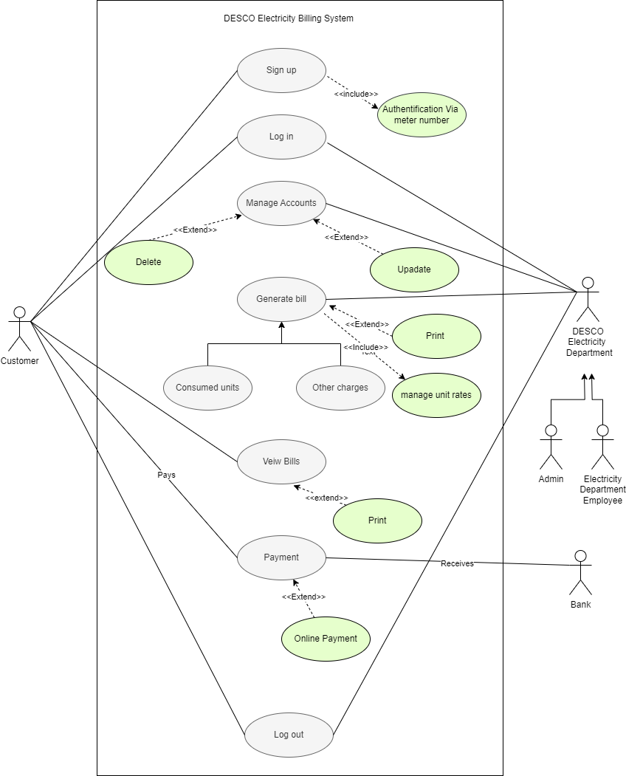

## Activity Diagram

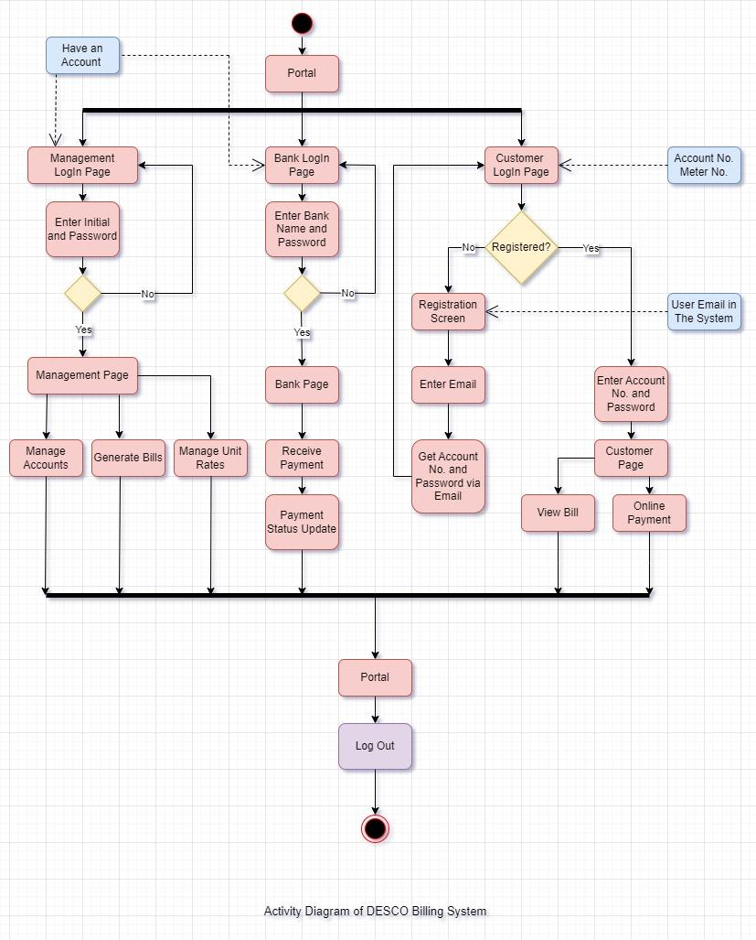

## State Diagram

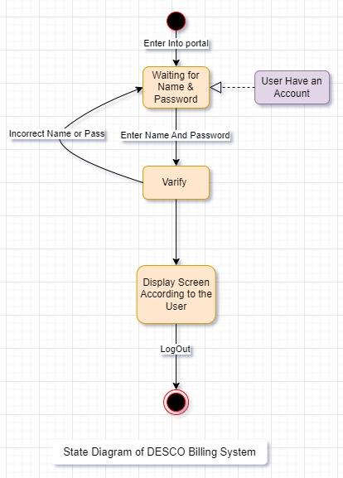

## Sequence Diagram (Customer)

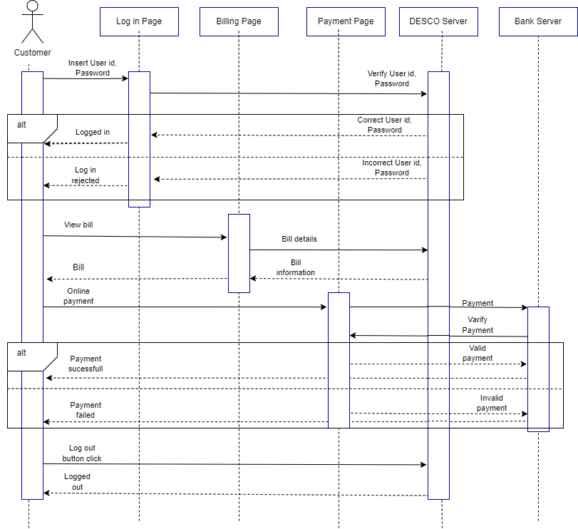

## Sequence Diagram (Management/Admin)

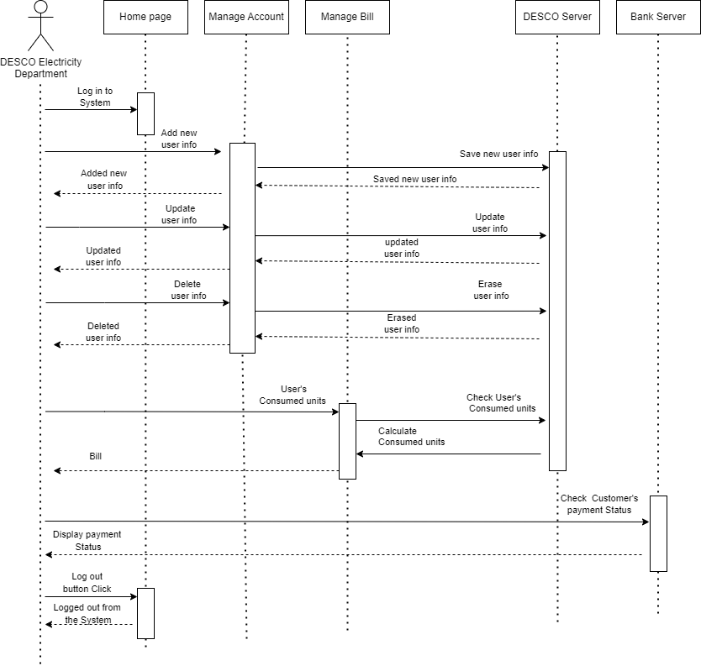



## ER Diagram

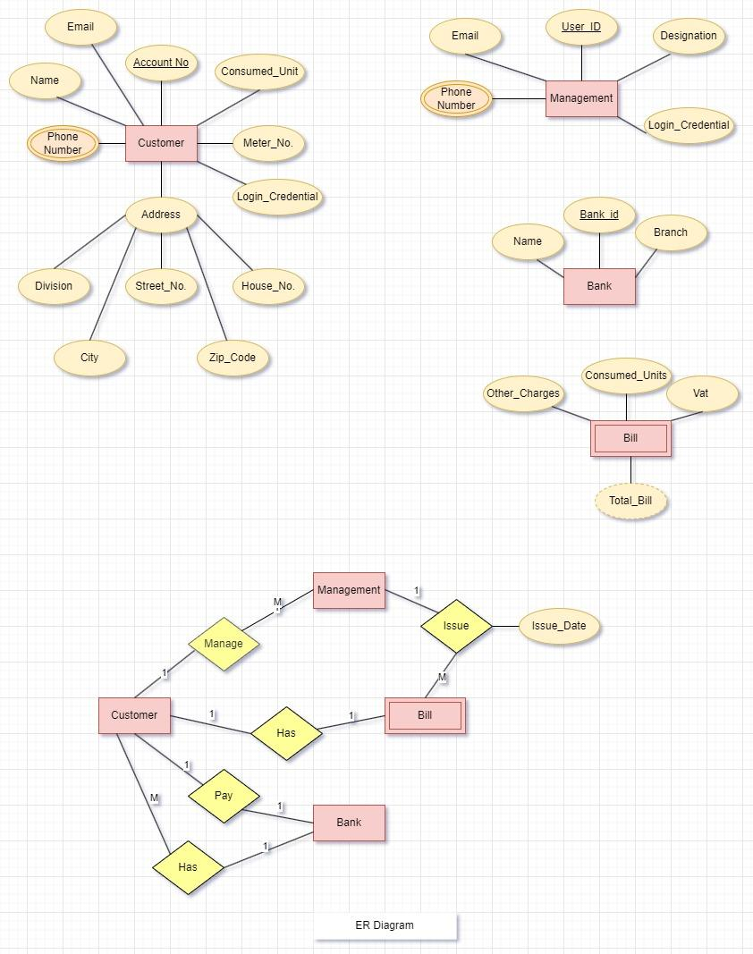

# Interactive Wireframing

Link: https://cloud.justinmind.com/usernote/prototype/3ba439db0d2afa41d755d2b5bbf79665c92997400eedb60f7a1e6b0cee58982b

## SOME Portal

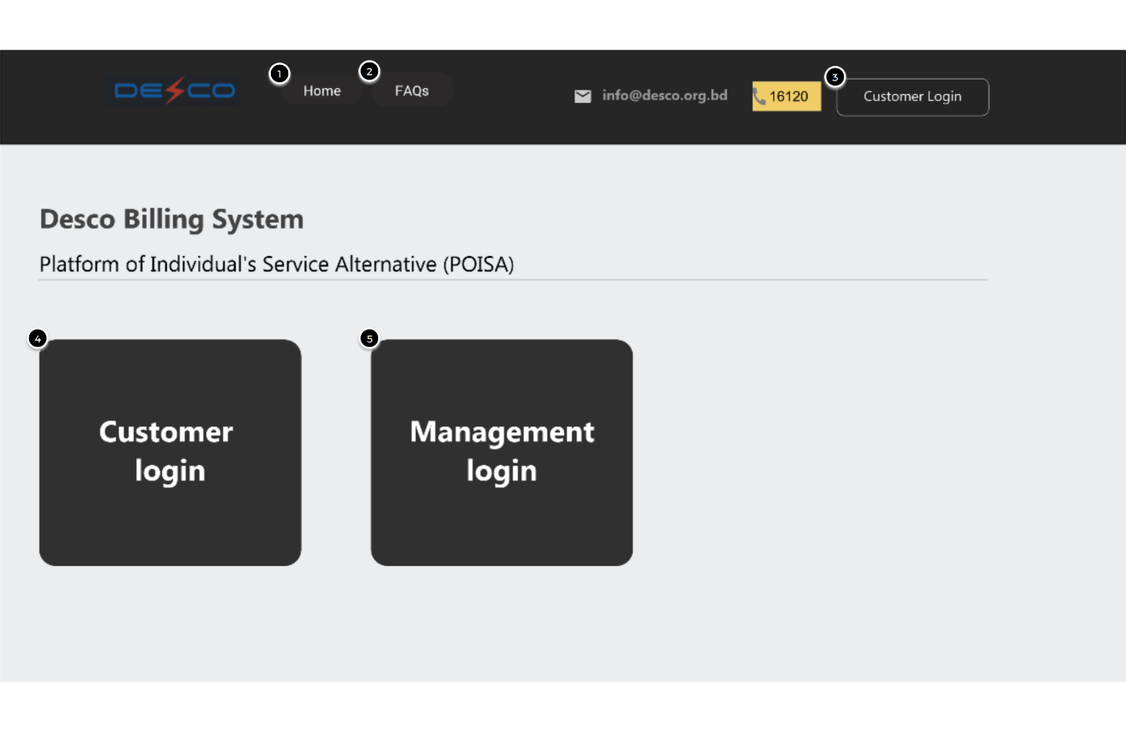

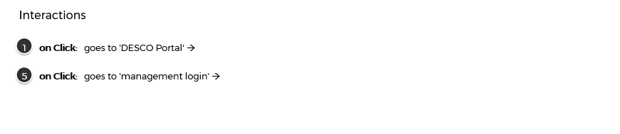

## Customer Register

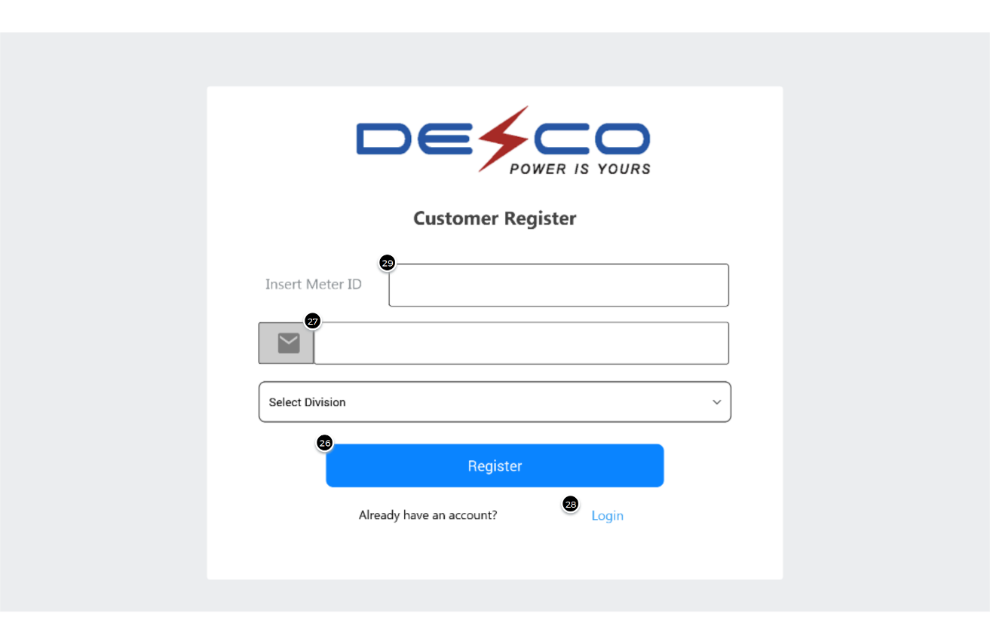

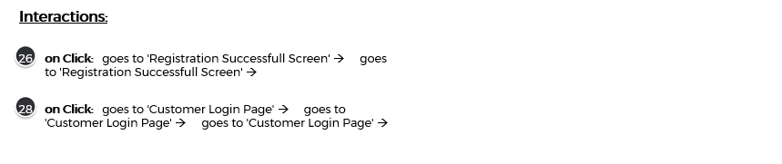

## Customer Login Page

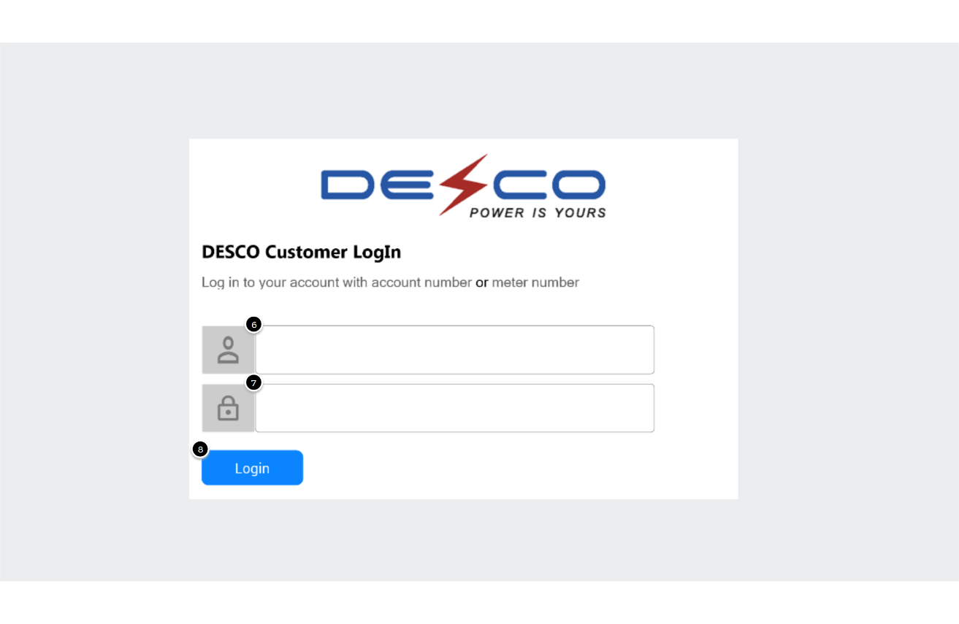



## Customer Information

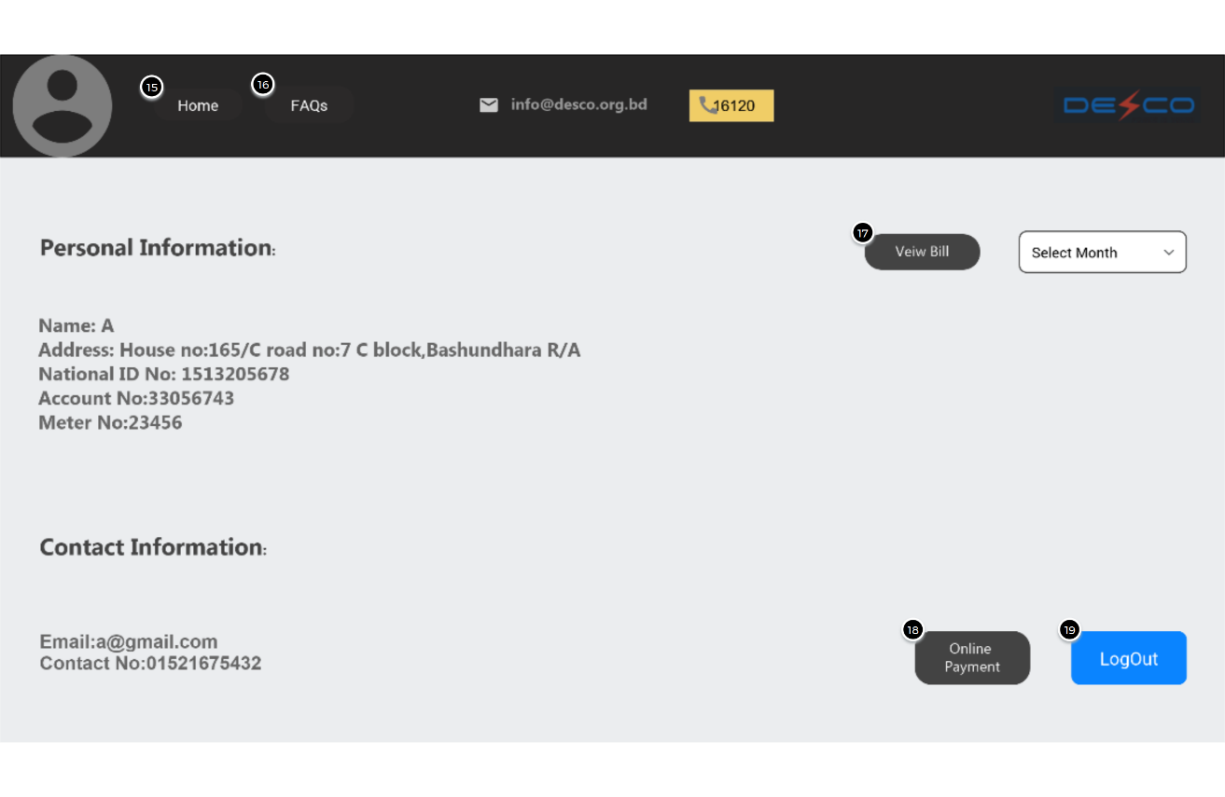

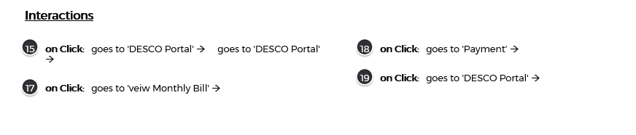

## View Monthly Bill

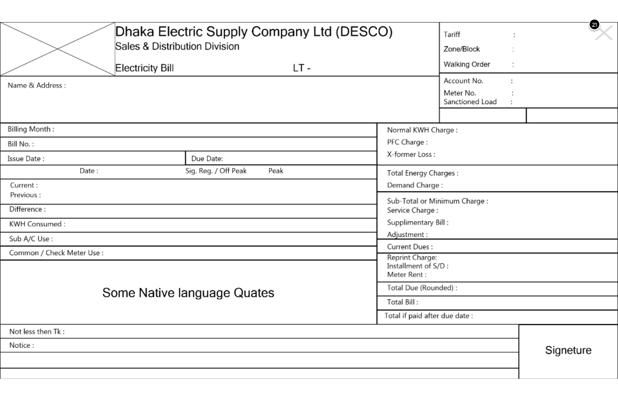

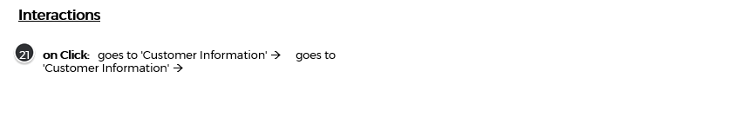

## Make Payment

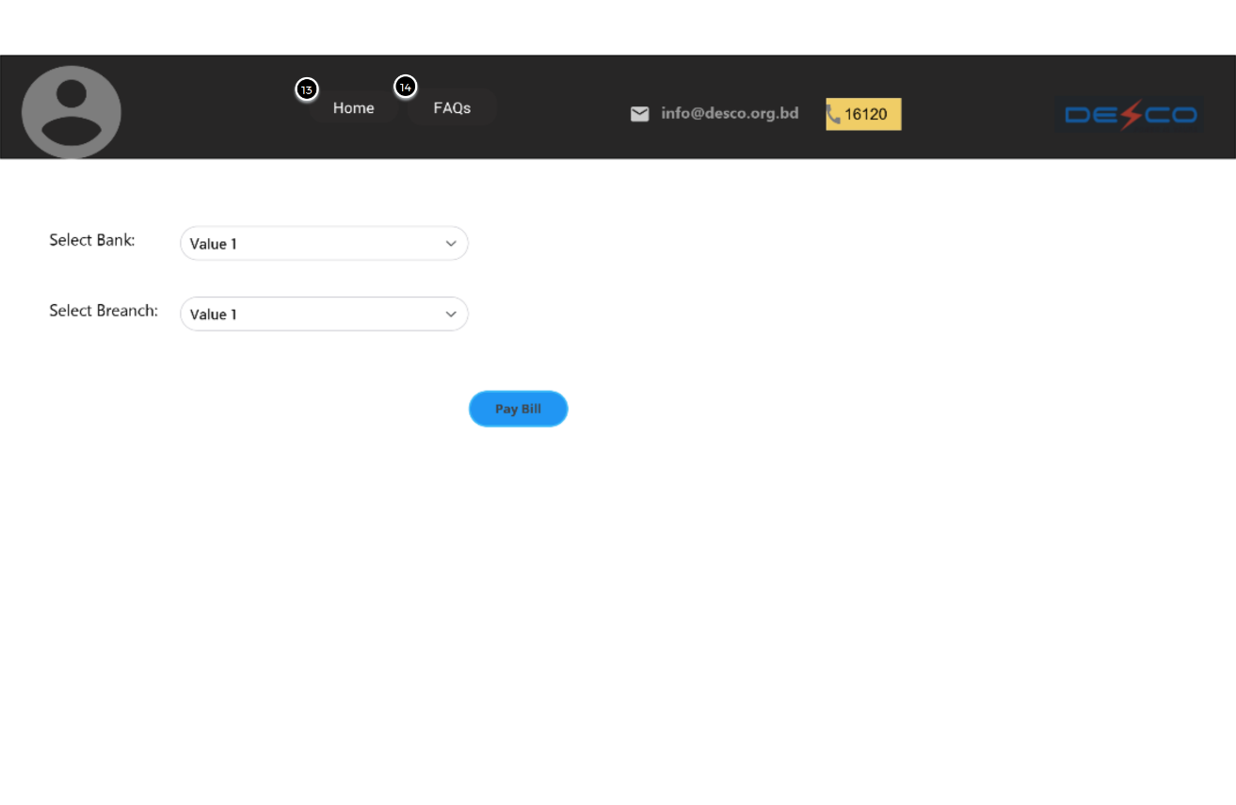

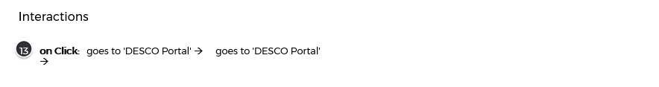

## Management Login

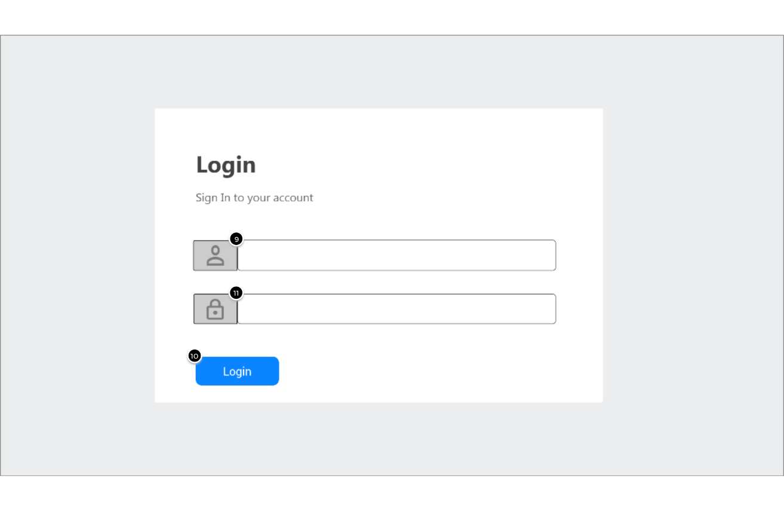



## Registration Success Screen

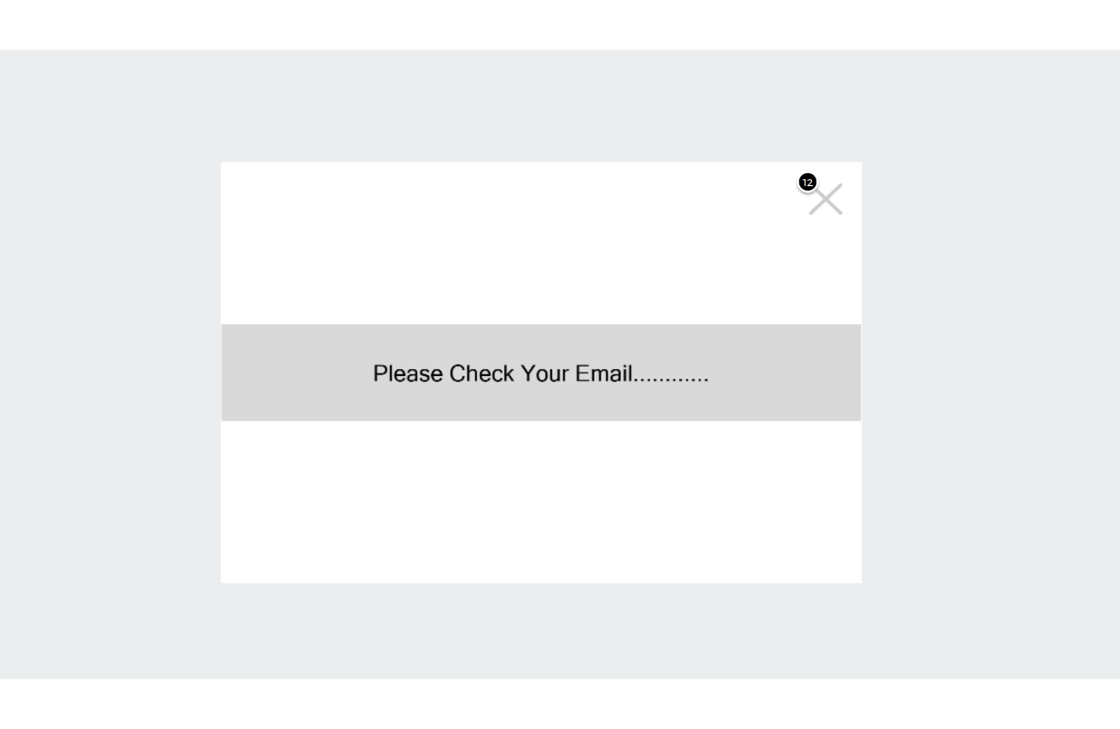

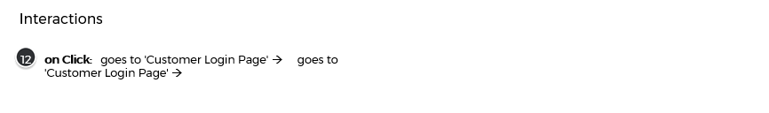

## Manage Account

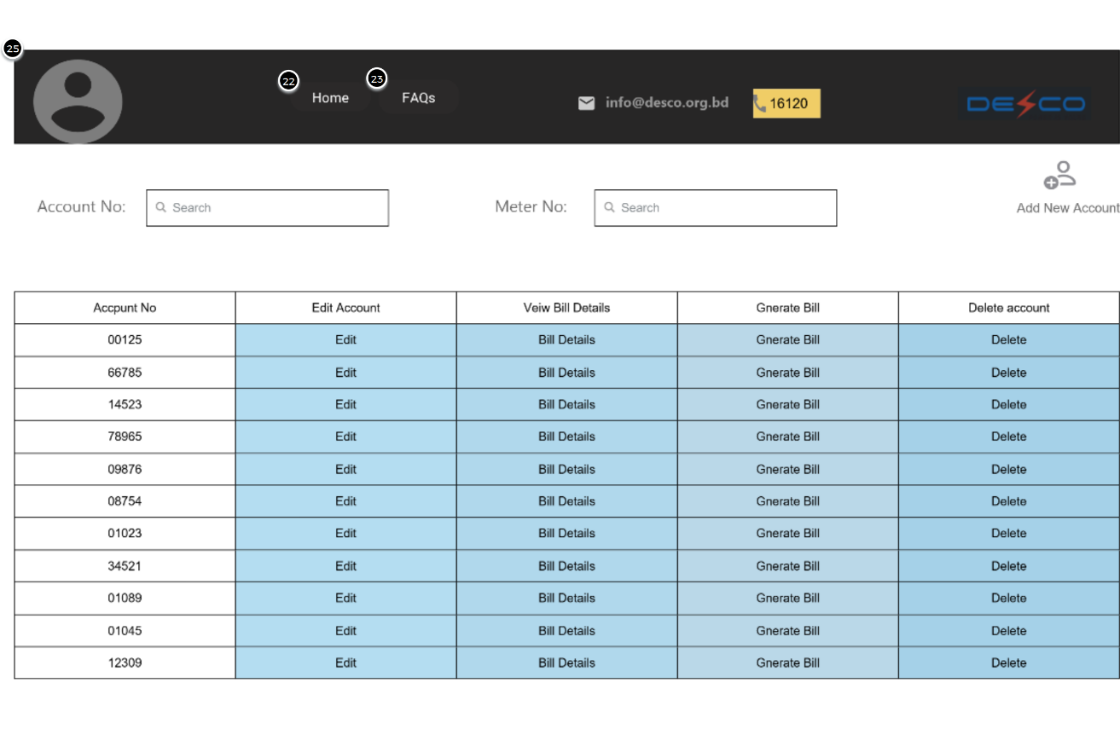

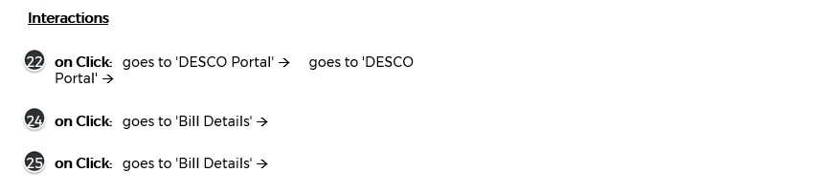

## Bill Management

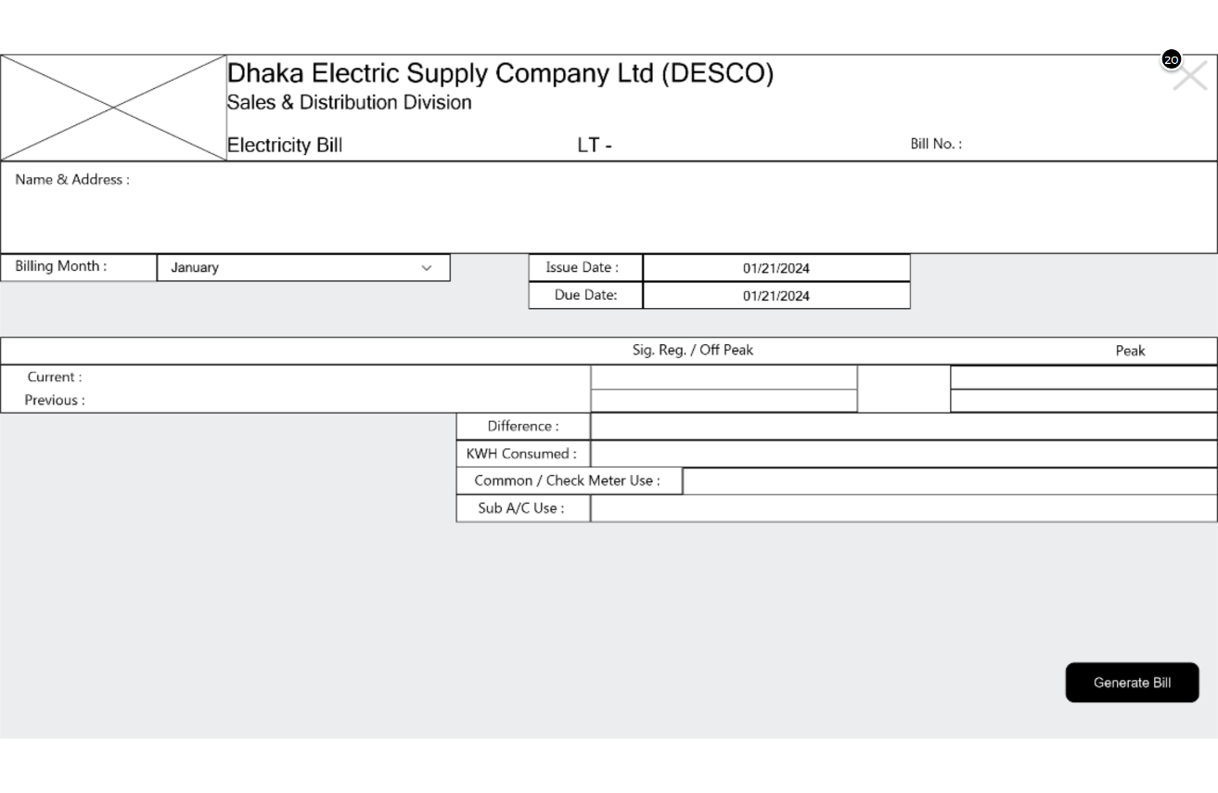

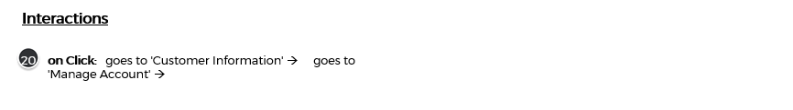

# Functionality wise Prototype Description

## Admin Functions

### 6.1.1 Delete User Account

Admin can remove user accounts from the system. This action is irreversible and affects the database directly.

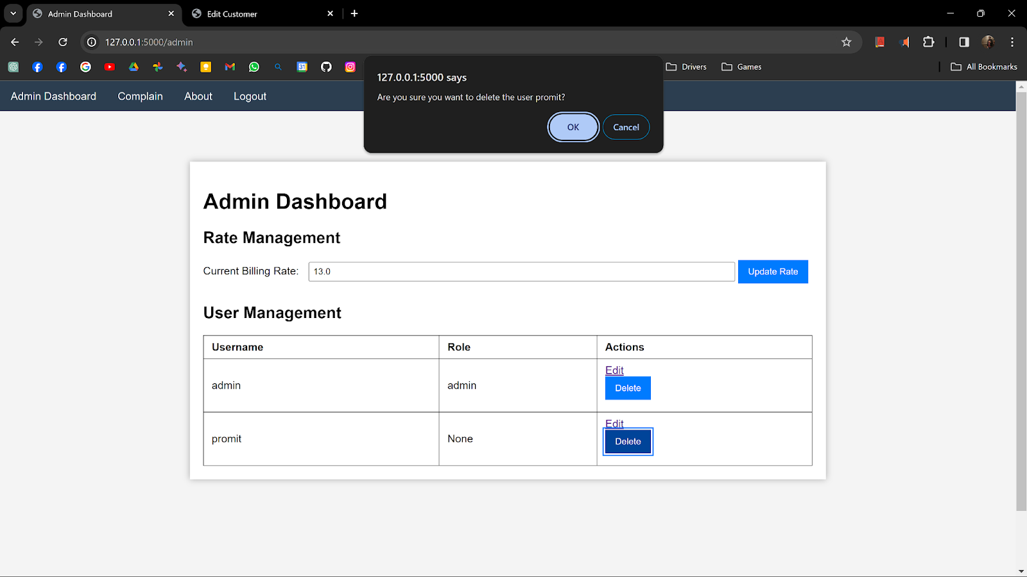



### 6.1.2 Edit Billing Rate

### 

### 6.1.3 View User’s Billing Information

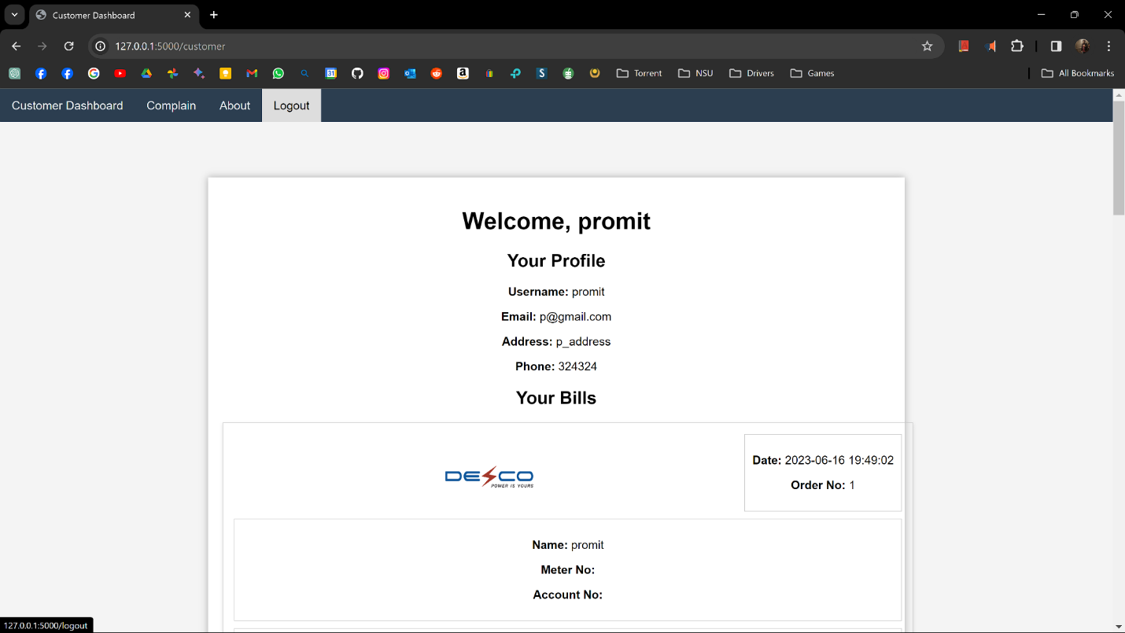

## 6.2 Customer Function

### 6.2.1 Download/View Billing Reports in PDF Format

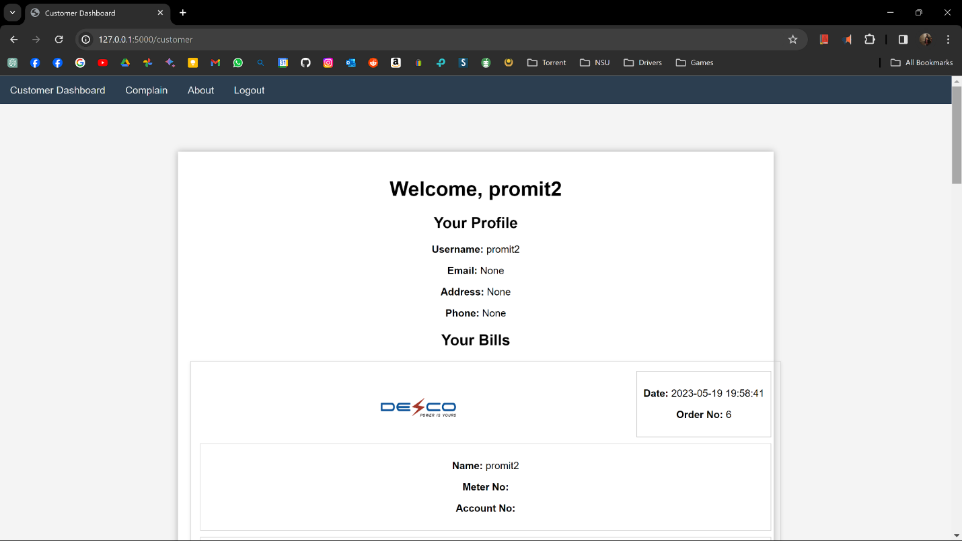

## 6.3 Implemented Login/Sign up

### 6.3.1 System Login

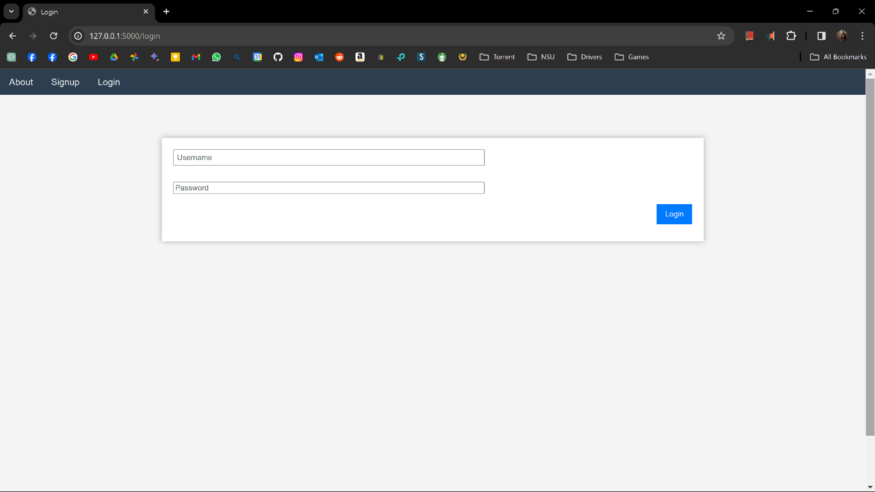

### 6.3.2 System Sign Up

# 

# Contribution Table

| Name | ID | Contribution Part | Signature |
| --- | --- | --- | --- |
|  |  | **SRS:** 1.5, 3.1-3.4  **Diagram:**   * Context Diagram * Activity Diagram * State Machine Diagram * ER Diagram   **Interactive Wireframing**  **Final Report**  **Presentation Slide** |  |
|  |  | **SRS:** 1.1-1.4, 1.6-1.7, 3.5  **Diagram:**   * Use Case * Customer Sequence Diagram * Admin Sequence Diagram * ER Diagram   **Interactive Wireframing**  **Final Report**  **Presentation Slide** |  |
| Sadman Sakib Khan Promit |  | **SRS:** 1.7 - 2.6  **Prototype**  **Presentation Slide** |  |
|  |  | - | - |